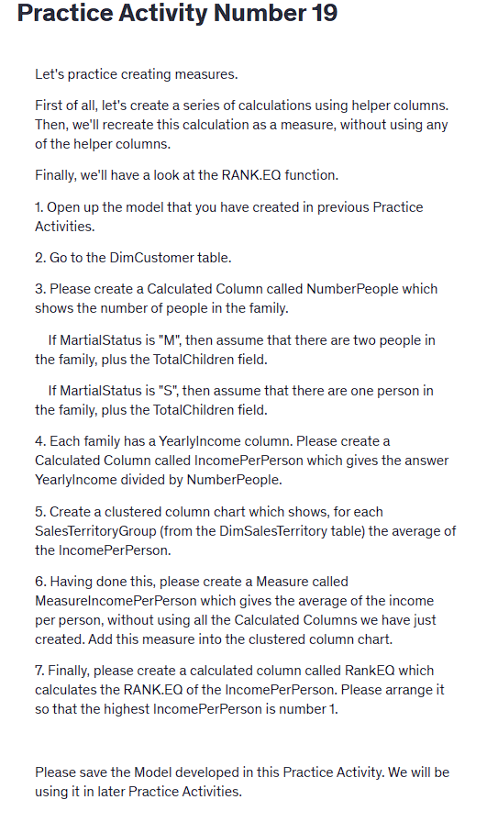  
  
Practice Activity Number 19

Let's practice creating measures.

First of all, let's create a series of calculations using helper columns. Then, we'll recreate this calculation as a measure, without using any of the helper columns.

Finally, we'll have a look at the RANK.EQ function.

1. Open up the model that you have created in previous Practice Activities.

2. Go to the DimCustomer table.

3. Please create a Calculated Column called NumberPeople which shows the number of people in the family.

If MartialStatus is "M", then assume that there are two people in the family, plus the TotalChildren field.

If MartialStatus is "S", then assume that there are one person in the family, plus the TotalChildren field.

4. Each family has a YearlyIncome column. Please create a Calculated Column called IncomePerPerson which gives the answer YearlyIncome divided by NumberPeople.

5. Create a clustered column chart which shows, for each SalesTerritoryGroup (from the DimSalesTerritory table) the average of the IncomePerPerson.

6. Having done this, please create a Measure called MeasureIncomePerPerson which gives the average of the income per person, without using all the Calculated Columns we have just created. Add this measure into the clustered column chart.

7. Finally, please create a calculated column called RankEQ which calculates the RANK.EQ of the IncomePerPerson. Please arrange it so that the highest IncomePerPerson is number 1.

Please save the Model developed in this Practice Activity. We will be using it in later Practice Activities.